A
PROJECT REPORT
ON

LEXORA – AN OFFLINE-FIRST AI ASSISTANT FOR LAWYERS

BY
TAABISH AHMED ANSARI – [Enrollment No.]



Faculty of Science & Technology, IFHE University
June–July 2026

A
PROJECT REPORT
ON

LEXORA – AN OFFLINE-FIRST AI ASSISTANT FOR LAWYERS

BY
TAABISH AHMED ANSARI – [Enrollment No.]

Project report submitted to IcfaiTech as a fulfillment of the requirements for the award of the Degree of B. Tech in Computer Science and Engineering under the supervision of [Faculty Supervisor Name].


Faculty of Science & Technology, IFHE University
June–July 2026

Declaration
I, Taabish Ahmed Ansari ([Enrollment No.]), hereby declare that this Project Report, titled “Lexora – An Offline-First AI Assistant for Lawyers,” is an authentic record of the work I personally conducted during the development of this project.
This project was completed under the invaluable guidance of my mentors. I extend my sincere gratitude to my faculty supervisor, [Faculty Supervisor Name], of the Department of Computer Science and Engineering, IcfaiTech, for his academic supervision and continuous support, whose practical expertise was essential to this endeavor.
I affirm that the work presented herein is original and that all external sources have been appropriately acknowledged and cited. This report, in whole or in part, has not been previously submitted to this or any other institution for the award of any degree or diploma.
I have adhered to the highest academic and ethical standards throughout this project and accept full responsibility for the content and conclusions presented in this document.

[Signature]
Taabish Ahmed Ansari
Date: 08-07-2026

CERTIFICATE
Faculty of Science & Technology, IFHE University
This is to certify that the project report titled “Lexora – An Offline-First AI Assistant for Lawyers” has been successfully completed by Taabish Ahmed Ansari (Enrollment No. [Enrollment No.]). This report is the culmination of his work on the design and development of an offline, on-device Artificial Intelligence assistant for legal professionals, carried out during June–July 2026.
It is further certified that the report is an authentic record of the student's own work and incorporates all modifications as suggested. The project fulfills the requirements for the Bachelor of Technology in Computer Science and Engineering and has been submitted to the Department of Computer Science and Engineering, The ICFAI Foundation for Higher Education.
The work presented in this report has not been submitted by the student for any other course or degree.

Signature of the Instructor Signature of the Student
Date: 08-07-2026
Place: Hyderabad

Acknowledgement
I would like to express my sincere gratitude to everyone who has supported and guided me throughout the development of the Lexora project. This project gave me the invaluable opportunity to work on a challenging and meaningful problem at the intersection of Artificial Intelligence and the legal profession.
I am particularly grateful to my faculty supervisor, [Faculty Supervisor Name], for his continuous mentorship, support, and guidance. His expertise and encouragement were instrumental in helping me navigate the complexities of local language models, semantic retrieval, and full-stack system design.
I would also like to extend my heartfelt appreciation to my faculty mentor, [Faculty Mentor Name], for consistent encouragement, insightful advice, and for ensuring that my project work remained aligned with my academic and professional goals. Finally, I am thankful to my peers and to everyone who directly or indirectly contributed to making this project a transformative learning experience. Their cooperation and willingness to share their knowledge made this journey both enjoyable and profoundly insightful.

Abstract
This report provides a comprehensive overview of the design and development of Lexora, an offline-first, on-device Artificial Intelligence assistant built for lawyers and legal professionals. The project was conceived to address a critical gap in the legal industry: lawyers handle highly confidential client information that cannot be sent to cloud-hosted AI services, yet they stand to benefit enormously from AI-powered assistance in managing clients, case files, conversations, and schedules.
Lexora runs entirely on local hardware. Text generation is performed by the TinyLlama-1.1B-Chat large language model executed through HuggingFace Transformers and PyTorch, while semantic understanding is powered by sentence-transformer embeddings and a custom NumPy-based cosine-similarity vector store persisted as JSON. On top of this foundation, the system delivers a ChatGPT-style legal chat interface, persistent per-client factual memory, an automatically constructed knowledge graph rendered with a custom HTML5 Canvas force-directed layout, offline Retrieval-Augmented Generation (RAG) over uploaded PDF case documents, a deterministic contradiction-detection engine that flags inconsistent client statements, an AI call assistant with live speech-to-text transcription and automatic meeting summaries, natural-language scheduling with Google Calendar integration, e-mail dispatch of case summaries, and a case-insights dashboard. The backend is built with FastAPI and the frontend with framework-free HTML, CSS, and JavaScript.
This project significantly enhanced my technical abilities in full-stack development, applied machine learning, natural language processing, and system design. It improved my confidence in building reliable end-to-end applications and gave me a deeper understanding of how private, secure, and scalable AI systems are engineered. This report summarizes the system architecture, the technologies mastered, the challenges overcome, and the lessons learned during this journey.

Table of Contents
Table of Illustrations ………………………………………………………………… 9
1. Introduction ………………………………………………………………………… 10
1.1. Background of the Project ………………………………………………… 10
1.2. Problem Statement …………………………………………………………… 10
1.3. Objectives of the Project ………………………………………………… 11
2. System Design and Technical Deep Dive ………………………………………… 12
2.1. System Architecture Overview …………………………………………… 12
2.2. The Local LLM Layer: TinyLlama-1.1B-Chat …………………………… 13
2.3. Offline Retrieval-Augmented Generation (RAG) ……………………… 14
2.4. Persistent Memory and the Knowledge Graph …………………………… 15
2.5. Contradiction Detection Engine ………………………………………… 16
2.6. AI Call Assistant and Live Transcription …………………………… 17
2.7. Scheduling, E-mail, and the Case Insights Dashboard ……………… 18
2.8. Backend API and Frontend Design ………………………………………… 19
3. Skills Acquired ……………………………………………………………………… 20
3.1. Technical Skills …………………………………………………………… 20
3.2. Soft Skills …………………………………………………………………… 21
4. Challenges and Learnings ………………………………………………………… 22
5. Conclusion …………………………………………………………………………… 23
6. References …………………………………………………………………………… 24

Table of Illustrations
Fig. 1: High-Level System Architecture of Lexora ……………………………… 12
Fig. 2: The ChatGPT-Style Offline Chat Interface ……………………………… 13
Fig. 3: Auto-Generated Client Knowledge Graph (Canvas Force-Directed Renderer) ……………………………… 14
Fig. 4: PDF Upload and Document Retrieval (Offline RAG) Interface ……………………………… 15
Fig. 5: Contradiction Warning Card Displayed During a Chat ……………………………… 16
Fig. 6: AI Call Assistant with Live Speech-to-Text Transcription ……………………………… 17
Fig. 7: Case Insights Dashboard with Chart.js Visualizations ……………………………… 18

1. Introduction
1.1. Background of the Project
Modern legal practice is document- and conversation-heavy. A practicing lawyer manages dozens of clients simultaneously, each with a growing trail of statements, phone calls, case documents, hearing dates, and correspondence. Tools such as ChatGPT have shown how transformative a conversational AI assistant can be, but they are fundamentally unsuitable for the legal domain in their cloud-hosted form: attorney–client privilege and data protection obligations make it unacceptable to transmit confidential case information to third-party servers.
Lexora was built to resolve this tension. It is an offline-first AI assistant in which every component that touches client data — the large language model, the text embeddings, the vector search index, and the knowledge graph — runs locally on the lawyer's own machine. All data and vector indexes are stored on disk as human-readable JSON files, so the application works without any internet connection and the user retains complete ownership of their data. An optional remote fallback (Google Gemini) exists purely as a silent reliability measure and is never required or surfaced in the interface.
1.2. Problem Statement
The project addresses four concrete problems faced by legal professionals:
1. Confidentiality: Cloud AI assistants require sending privileged client data to external servers, which is ethically and legally problematic for lawyers.
2. Fragmented memory: Client facts are scattered across notebooks, e-mails, and memory. There is no single system that remembers everything a client has ever said and can recall it instantly and semantically.
3. Inconsistency detection: Clients sometimes make contradictory statements weeks apart (“I was at the office at 5 PM” versus “I was not at the office”). Catching such contradictions manually across long case histories is error-prone.
4. Administrative overhead: Summarizing calls, extracting action items, scheduling hearings, and e-mailing case summaries consume time that could be spent on legal work.
1.3. Objectives of the Project
The primary objectives of the Lexora project were:
• To build a fully offline conversational AI assistant using an on-device LLM (TinyLlama-1.1B-Chat) with GPU acceleration where available.
• To implement persistent, per-client factual memory with semantic recall, so that every statement a client makes is embedded, indexed, and retrievable in future conversations.
• To automatically construct a knowledge graph of entities and relations for each client and render it interactively in the browser.
• To support offline Retrieval-Augmented Generation over uploaded PDF case documents with source citation.
• To detect contradictions between a client's new statements and their prior testimony using a deterministic, reliable engine.
• To provide an AI call assistant capable of live transcription, real-time memory commits, automatic meeting summaries, and action-item extraction.
• To round out the product with natural-language scheduling, e-mail dispatch of case summaries, client management, and a case-insights dashboard.

2. System Design and Technical Deep Dive
2.1. System Architecture Overview
Lexora follows a clean layered architecture. A FastAPI web server (app.py) exposes a REST API and hosts the static frontend. The orchestration layer (chat.py) coordinates every chat turn and call event. Beneath it sit four specialist modules: llm.py (text generation), rag.py (embeddings, vector store, and PDF ingestion), memory.py (clients, statements, knowledge graph, contradiction engine, dashboard, and activity log), and calendarx.py / mailer.py / telephony.py for scheduling, e-mail, and real phone-call integration respectively. Persistence is deliberately simple and portable: all case data lives in data/store.json and all vectors in chroma_db/documents.json and chroma_db/memory.json, guarded by re-entrant locks for thread safety and flushed to disk on every write, so closing and reopening the application restores the entire state exactly.
[Fig. 1: High-Level System Architecture of Lexora — insert diagram/screenshot here]
A single chat turn flows as follows: the user's message is stored as a statement and embedded into the memory index; a contradiction check runs against the client's prior statements; context is assembled from semantic memory recall, RAG document chunks, recent chat turns, and any detected contradiction; TinyLlama generates the reply, which is cleaned by regex post-processing; entities and relations are extracted and merged into the client's knowledge graph; and finally everything is persisted to disk.
2.2. The Local LLM Layer: TinyLlama-1.1B-Chat
Text generation is powered by TinyLlama-1.1B-Chat, loaded lazily through HuggingFace Transformers and PyTorch. The model runs in float16 on a CUDA GPU when available and falls back to float32 on CPU. Generation uses the tokenizer's native chat template with sampling controls — temperature, top-p (nucleus) sampling, and a repetition penalty — to balance fluency with factual restraint. Because small models occasionally hallucinate URLs or echo their context, a regex-based output-hygiene pass strips such artifacts before the reply reaches the user.
The LLM layer also provides structured generation: generate_json() prompts the model for a JSON object and then extracts the first balanced JSON structure from the raw output, tolerating code fences and surrounding prose. This is used for knowledge-graph extraction and action-item extraction. A silent, environment-gated fallback to Google Gemini exists for the rare case where the local model fails to load; it is never referenced in the user interface, preserving the offline-first product identity.
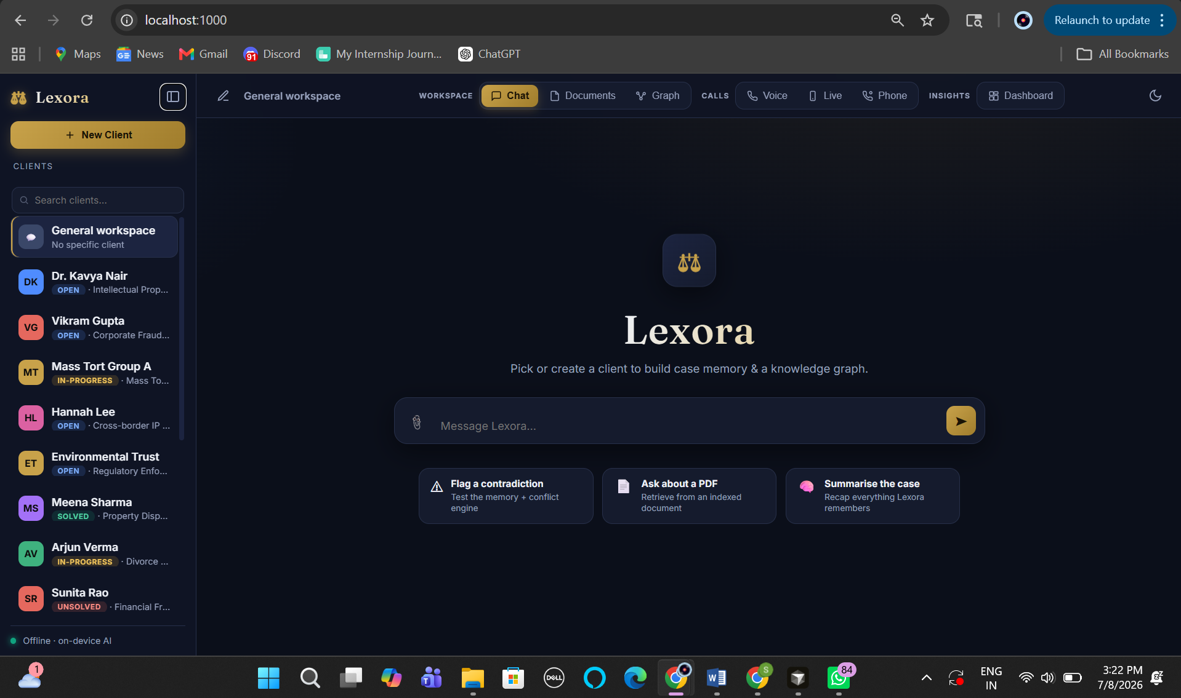
Fig. 2: The ChatGPT-Style Offline Chat Interface
2.3. Offline Retrieval-Augmented Generation (RAG)
Lawyers can upload PDF case documents which become searchable knowledge for the assistant. The ingestion pipeline extracts text with pypdf, splits it into fixed-size overlapping chunks (900 characters with 150-character overlap), embeds each chunk with a sentence-transformers model, and stores the vectors with metadata identifying the source file and owning client.
A notable engineering decision was the vector store itself. The initially chosen ChromaDB build suffered a fatal compaction bug in this environment that silently dropped every vector. It was replaced with a purpose-built, dependency-light NumPy cosine-similarity index: embeddings are L2-normalized so cosine similarity reduces to a dot product, and the index persists as JSON on disk. This delivered the same retrieval quality with zero failure points. At question time, the query is embedded and the top-k most similar chunks (filtered to the active client, falling back to the shared library) are injected into the prompt, and answers cite their source documents.
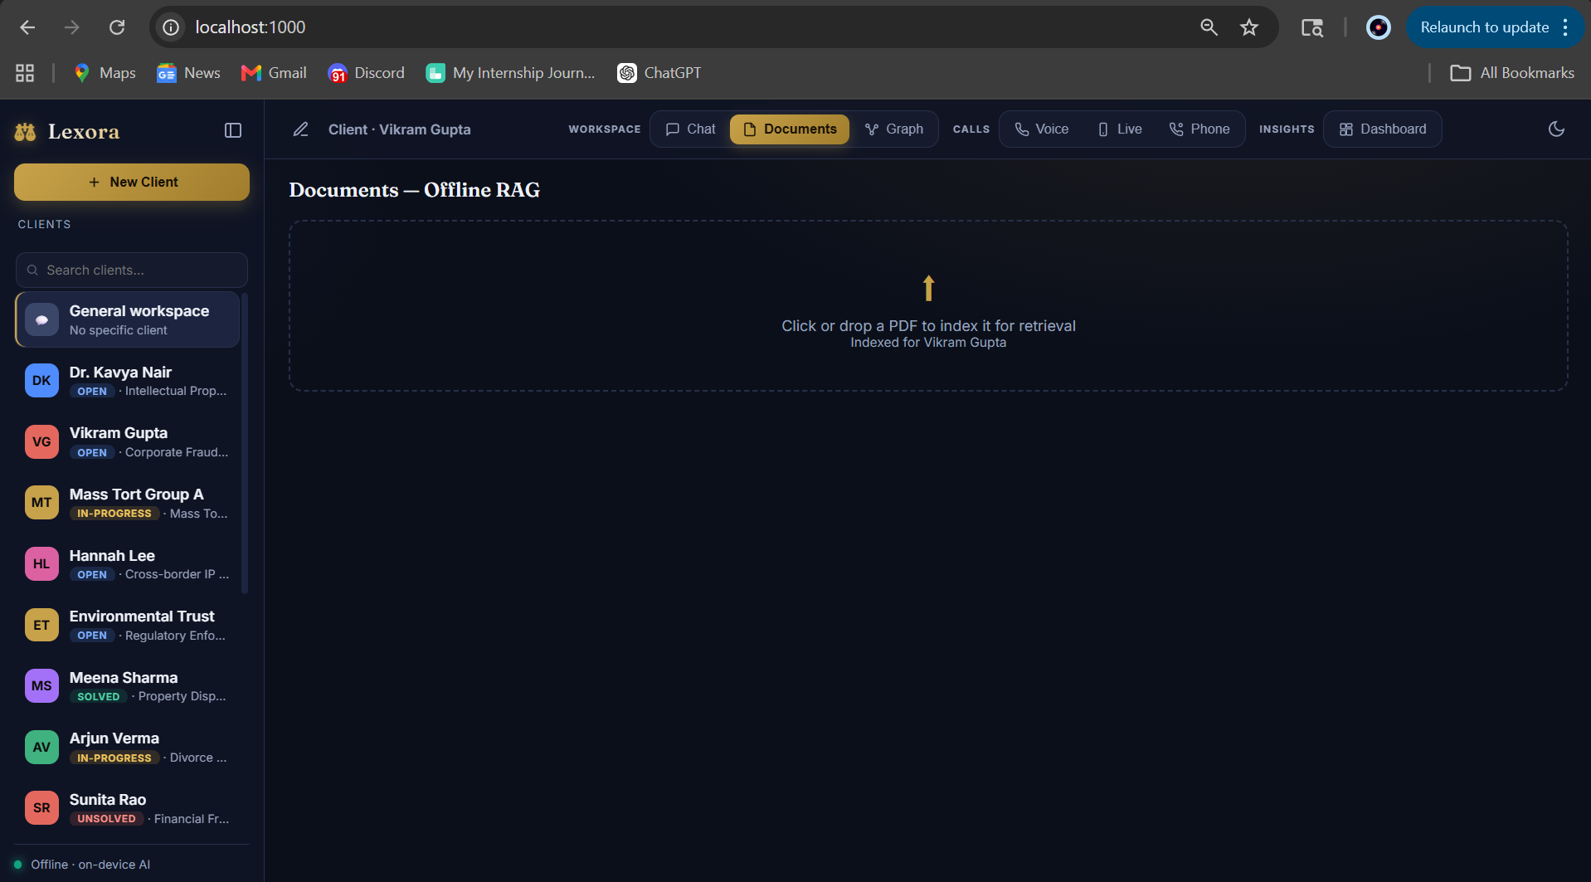
Fig. 4: PDF Upload and Document Retrieval (Offline RAG) Interface
2.4. Persistent Memory and the Knowledge Graph
Every factual message a client sends is stored twice: as a plain statement in store.json and as a normalized embedding in the memory vector index. During later conversations, the current message is embedded and the most semantically similar past statements are recalled and placed in the model's context — giving Lexora a persistent, ChatGPT-like memory that survives restarts.
In parallel, TinyLlama is prompted to return a JSON structure of entities and relations for each factual message. A heuristic sanitization layer drops hallucinated URLs and generic placeholder labels (such as “PERSON” or “DATE”) that small models sometimes emit. Nodes and edges are merged case-insensitively into the client's graph, so the same entity mentioned in different conversations connects automatically, and orphan entities are attached to the client node. The graph is stored as simple node and edge lists — no graph database is required — and is rendered in the browser by a fully custom HTML5 Canvas force-directed renderer featuring node repulsion, spring attraction along edges, center gravity, drag-to-move interaction, and color-coding by entity type, all with zero external libraries.
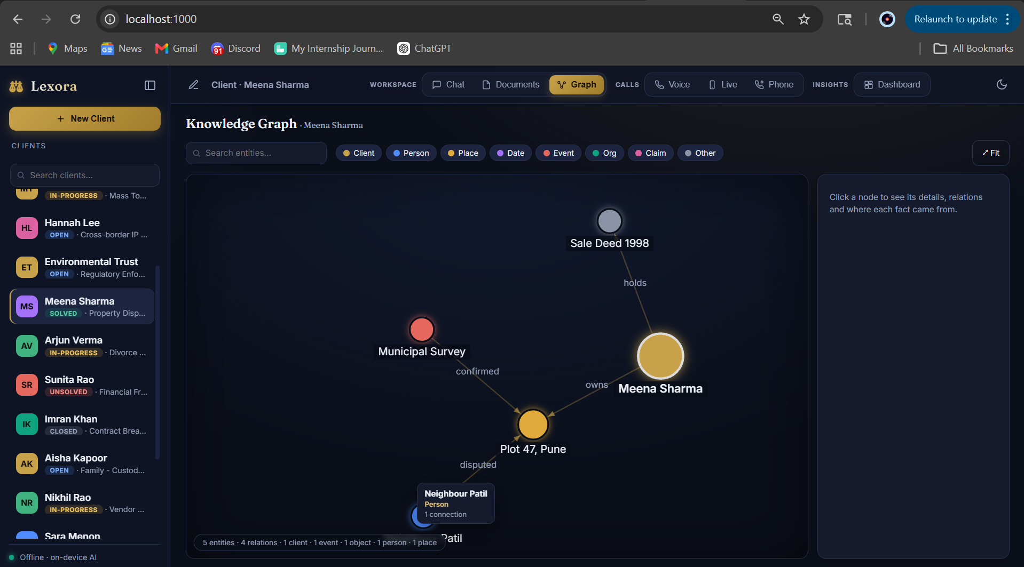
Fig. 3: Auto-Generated Client Knowledge Graph
2.5. Contradiction Detection Engine
Reliability was paramount for contradiction detection, so this feature is deliberately not delegated to the 1.1-billion-parameter model. Instead, a deterministic engine runs on every new statement. The statement is embedded and the most similar prior statements for that client are recalled from the memory index. Two rule families then apply: a negation/polarity check flags cases where two statements share the same subject (shared tokens plus cosine similarity of at least 0.45) but one affirms while the other denies; and a numeric/time-conflict check flags statements about the same subject that quote different numbers or clock times (for example, 5 PM versus 9 PM) while skipping corroborating evidence. When a conflict is found, the chatbot explains the contradiction in natural language and the UI displays a guaranteed red warning card.
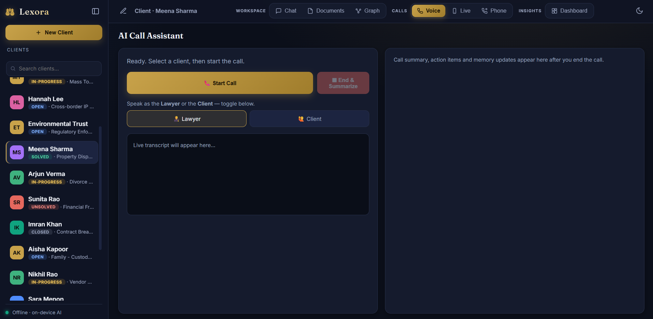
Fig. 5: Contradiction Warning Card Displayed During a Chat
2.6. AI Call Assistant and Live Transcription
Lexora includes both a demo call assistant and a live-call mode. Speech-to-text uses the browser-native Web Speech API in Chrome or Edge, so no audio ever leaves the machine; for a real two-phone call, the phone is placed on speaker next to the laptop. Each finalized utterance is posted to the /api/live endpoint, where it is committed to memory and the knowledge graph in real time with live contradiction checks.
The assistant can even create clients automatically mid-call: a regex-based name detector (recognizing patterns like “my name is …”) combined with a keyword-based case-type classifier (theft → Criminal, divorce → Divorce, and so on) spins up a new client record on the fly when none is selected. When the call ends, TinyLlama writes a meeting summary, and action items are extracted through LLM JSON generation with a robust regex fallback keyed on cue words such as “will,” “send by Friday,” and “follow up.” An optional Twilio integration (telephony.py) supports genuine telephone calls with server-side transcription callbacks.
2.7. Scheduling, E-mail, and the Case Insights Dashboard
A natural-language calendar module (calendarx.py) detects scheduling intent in chat messages using cue words, carefully excluding past-testimony sentences. It extracts clock times with regular expressions before parsing dates with the dateparser library (preferring future dates), synthesizes a clean event title by peeling away filler words, detects conflicts with existing events, and produces a one-click “Add to Google Calendar” link. Case summaries can be e-mailed to clients directly via Gmail SMTP using an app password (mailer.py).
The Case Insights Dashboard aggregates clients by case status and case type, along with totals for calls, statements, documents, and contradictions, rendered as doughnut and bar charts using a locally vendored copy of Chart.js on a dark theme. An activity log records every significant action — client created, graph updated, contradiction detected, call recorded, document uploaded, client deleted — providing a who-did-what-when audit trail.
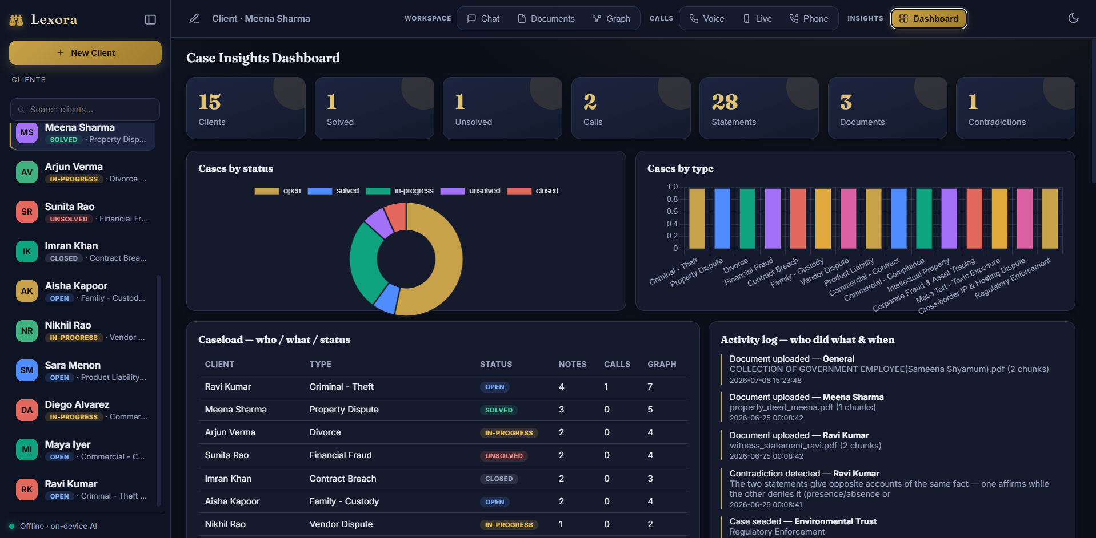
Fig. 7: Case Insights Dashboard with Chart.js Visualizations
2.8. Backend API and Frontend Design
The backend exposes a clean REST API through FastAPI with Pydantic request validation: chat (/api/chat), client CRUD (/api/clients with POST, PATCH, and DELETE), per-client messages, statements, graphs, and calls, PDF upload (/api/upload via multipart), document listing, live-call turns (/api/live), call processing (/api/call), dashboard aggregation (/api/dashboard), health checks, and Twilio webhook endpoints. Deleting a client purges them everywhere — chat history, statements, graph, calls, and all vectors in both indexes. A no-cache middleware guarantees the browser always loads the latest UI assets.
The frontend is intentionally framework-free: vanilla HTML, CSS, and JavaScript deliver a dark, ChatGPT-style interface with a client sidebar, a streaming-style typing indicator, modals for client management, the Canvas knowledge-graph view, and the dashboard. Avoiding frameworks kept the application light, fully offline, and easy to reason about.

3. Skills Acquired
3.1. Technical Skills
• Applied Machine Learning and NLP: Running quantization-aware local LLM inference with HuggingFace Transformers and PyTorch (fp16 on CUDA), prompt engineering for small models, structured JSON generation, and output sanitization.
• Semantic Search and RAG: Sentence-transformer embeddings, vector normalization and cosine similarity, chunking strategies with overlap, metadata filtering, and building a persistent vector store from first principles with NumPy.
• Backend Engineering: Designing REST APIs with FastAPI and Pydantic, multipart file uploads, middleware, thread-safe persistence with re-entrant locks, and webhook integration with Twilio telephony.
• Frontend Engineering: Framework-free JavaScript application structure, HTML5 Canvas programming including a force-directed graph layout algorithm, Chart.js data visualization, and the Web Speech API for browser-native speech recognition.
• Algorithm Design: Deterministic heuristics for contradiction detection (polarity and numeric/time conflicts), regex-based information extraction, and natural-language date/time parsing.
• Software Architecture: Layered module design, offline-first system thinking, graceful degradation and silent fallbacks, and pragmatic persistence with human-readable JSON.
3.2. Soft Skills
• Problem Decomposition: Breaking a large product vision into independently buildable, testable features.
• Engineering Judgment: Choosing reliability over sophistication where it mattered — for example, backing the small LLM with deterministic engines for must-be-correct tasks, and replacing a failing third-party database with a simpler in-house solution.
• Documentation and Communication: Writing clear technical documentation of the stack, data flow, and setup procedures.
• Time Management and Self-Direction: Planning and executing a multi-feature project end-to-end within a limited timeframe.

4. Challenges and Learnings
Working with a 1.1-billion-parameter model was the defining challenge of the project. TinyLlama is small enough to run on consumer hardware but exhibits variance: it can hallucinate URLs, echo its context, or emit malformed JSON. The learning was to treat the model as one component in a pipeline rather than an oracle — surrounding it with regex-based output hygiene, balanced-JSON extraction, heuristic sanitization of graph labels, and deterministic engines for correctness-critical tasks such as contradiction detection and action-item extraction. This layered defense made demos reliable regardless of the model's variance.
A second major challenge was the vector database. ChromaDB, the standard choice, threw a fatal mismatched-types compaction error on a fresh database in this environment and silently dropped every stored vector. Debugging a third-party storage engine mid-project was impractical, so the pragmatic solution was to write a minimal NumPy cosine index that persists to JSON — an instructive lesson that understanding the underlying mathematics (normalized embeddings make cosine similarity a dot product) can make the “hard” dependency unnecessary.
Other challenges included parsing natural-language dates without misreading times as days (solved by extracting clock times with regex before date parsing), distinguishing scheduling requests from past testimony in the calendar module, merging knowledge-graph entities across conversations without duplication, and ensuring complete data hygiene when deleting a client across every store and index. Each of these sharpened my instinct for edge cases and for designing systems that fail safely.

5. Conclusion
Lexora demonstrates that a genuinely useful, private, and trustworthy AI assistant for the legal profession can run entirely on local hardware. By combining an on-device LLM, local embeddings, a custom vector store, and deterministic reliability engines, the system delivers conversational assistance, persistent client memory, document intelligence, contradiction detection, call summarization, scheduling, and case analytics — all without a single byte of client data leaving the machine.
The project was a transformative learning experience spanning the full breadth of modern software engineering: applied machine learning, natural language processing, information retrieval, backend and frontend development, and system architecture. Beyond the technology, it taught the value of engineering pragmatism — knowing when to rely on a model and when to rely on an algorithm, and when a simple, well-understood solution beats a heavyweight dependency.
Future work could include upgrading to newer small models (such as Phi-3 or Llama-3.2-1B), fine-tuning on legal corpora, richer document understanding (OCR for scanned filings), multi-user support with authentication, and packaging the application as a signed desktop installer for non-technical users.

6. References
1. TinyLlama: An Open-Source Small Language Model — Zhang, P., et al. (2024). https://github.com/jzhang38/TinyLlama
2. HuggingFace Transformers Documentation — https://huggingface.co/docs/transformers
3. PyTorch Documentation — https://pytorch.org/docs
4. Sentence-Transformers: Sentence Embeddings using Siamese BERT-Networks — Reimers, N., & Gurevych, I. (2019). https://www.sbert.net
5. Retrieval-Augmented Generation for Knowledge-Intensive NLP Tasks — Lewis, P., et al. (2020). NeurIPS.
6. FastAPI Documentation — https://fastapi.tiangolo.com
7. Pydantic Documentation — https://docs.pydantic.dev
8. pypdf Documentation — https://pypdf.readthedocs.io
9. Chart.js Documentation — https://www.chartjs.org/docs
10. Web Speech API — MDN Web Docs. https://developer.mozilla.org/en-US/docs/Web/API/Web_Speech_API
11. Twilio Programmable Voice Documentation — https://www.twilio.com/docs/voice
12. dateparser Documentation — https://dateparser.readthedocs.io
13. Force-Directed Graph Drawing — Fruchterman, T. M. J., & Reingold, E. M. (1991). Graph Drawing by Force-Directed Placement.

